Project Planning Phase
Project Planning Template (Product Backlog, Sprint Planning, Stories, Story points)

Date | 22 October 2022
Team ID | PNT2022TMID48153
Project Name | Emerging Methods for Early Detection of Forest Fires
Maximum Marks | 8 Marks

Product Backlog, Sprint Schedule, and Estimation (4 Marks)

Sprint | Functional Requirement (Epic) | User Story Number | User Story / Task | Story Points | Priority | Team Members
Sprint-1 | Data collection | USN-1 | Artificial Intelligence is a data hunger technology, it depends heavily on data, without data, it is impossible for a machine to learn. It is the most crucial aspect that makes algorithm training possible. In Convolutional Neural Networks, as it deals with images, we need training and testing data set. It is the actual data set used to train the model for performing various actions.The required datas should be collected | 1 | Medium | B.FAHMIDHA  M.ANNAPOORANI  P.DAYANA  D.SANTHI
Sprint-1 | Image preprocessing | USN-2 | The dataset images are to be preprocessed before giving it to the model. | 2 | High | B.FAHMIDHA  M.ANNAPOORANI  P.DAYANA  D.SANTHI
Sprint-2 | Model building | USN-3 | The drone videos will be split into frames to detect the fire. | 3 | High | B.FAHMIDHA  M.ANNAPOORANI  P.DAYANA  D.SANTHI
Sprint-3 | Video analysis | USN-4 | After the fire is detected the alert message have to be sent . | 2 | High | B.FAHMIDHA  M.ANNAPOORANI  P.DAYANA  D.SANTHI
Sprint-4 | Train CNN model on IBM | USN-5 | The exact location of the drone will be predicted and sent along with the alert message. | 2 | High | B.FAHMIDHA  M.ANNAPOORANI  P.DAYANA  D.SANTHI

Project Tracker, Velocity & Burndown Chart: (4 Marks)

Sprint | Total Story Points | Duration | Sprint Start Date | Sprint End Date (Planned) | Story Points Completed (as on Planned End Date) | Sprint Release Date (Actual)
Sprint-1 | 20 | 6 Days | 24 Oct 2022 | 29 Oct 2022 | 10 | 29 Oct 2022
Sprint-2 | 20 | 6 Days | 31 Oct 2022 | 05 Nov 2022 | 10 | 05 Nov 2022
Sprint-3 | 20 | 6 Days | 07 Nov 2022 | 12 Nov 2022 | 10 | 12 Nov 2022
Sprint-4 | 20 | 6 Days | 14 Nov 2022 | 19 Nov 2022 | 10 | 19 Nov 2022

Velocity:

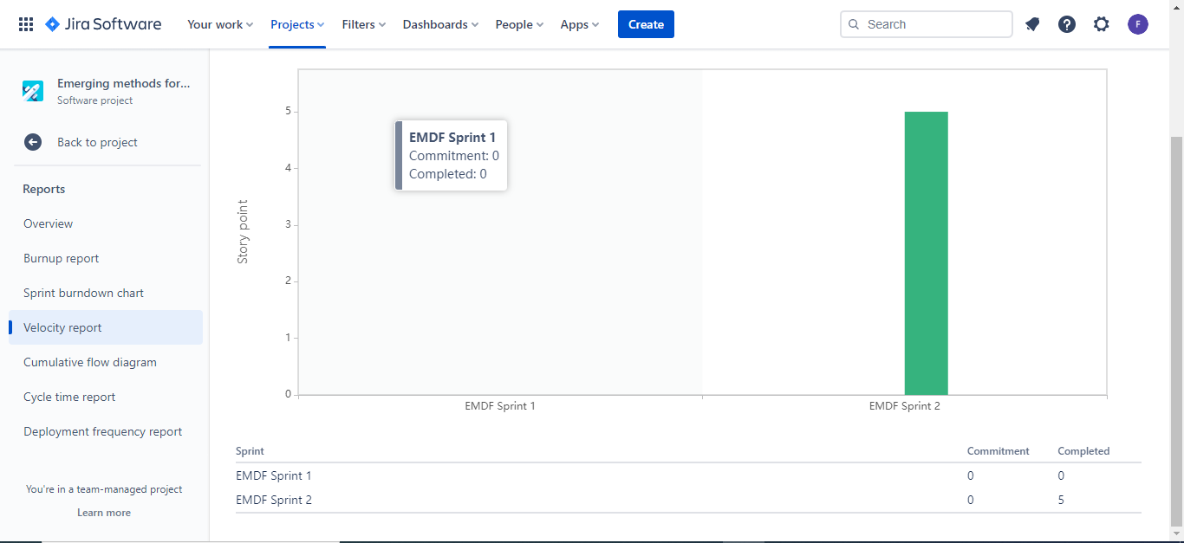

Burndown Chart:

